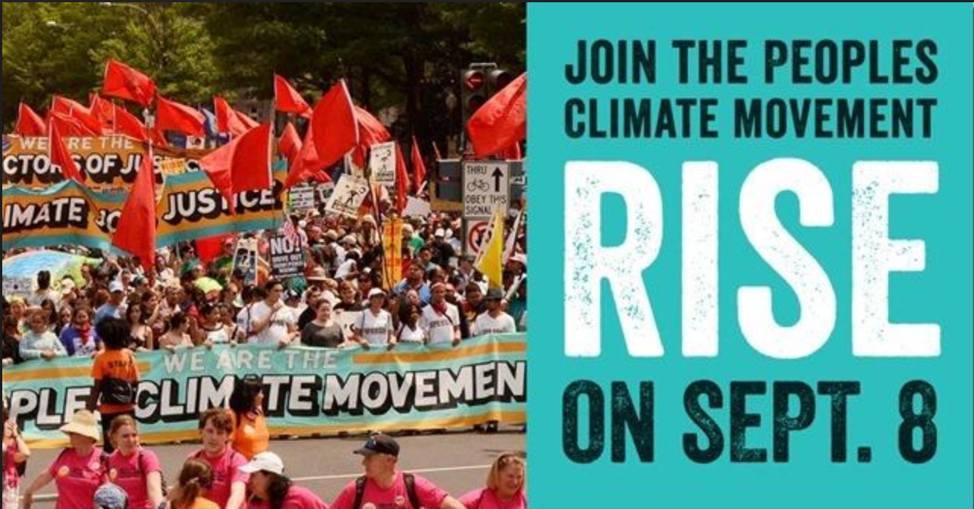
FOR IMMEDIATE RELEASE
Contact #: 732-671-5917
RED BANK, NJ: On Saturday, September 8th at 10 AM residents of Monmouth County, NJ, will meet in Riverside Gardens Park, 40 West Front Street, Red Bank, to participate in an international effort to support Clean Energy. The March and rally of MONMOUTH COUNTY for CLEAN ENERGY is part of RISE for Climate, Jobs, and Justice, an activity organized by the Peoples Climate Movement and hundreds of partners from across the United State and around the world.
It will bring out tens of thousands of people to show our leaders that we demand real action on climate change. We want a 100% clean energy economy, family-sustaining jobs, economic justice and access to clean air and water for all.
The local march will follow a designated, short route through Red Bank sidewalks to a family-friendly rally at Marine Park, 1 Marine Park, off East Front Street. At the rally, speakers and exhibits will describe easy-to-take steps individuals can take to enhance the international push to make clean energy a reality. See the display of plug-in electric cars. The rally concludes at noon. Local sponsors include the Sierra Club Jersey Shore Group, 350.org, Climate Reality Project - Central Jersey Chapter, Citizens’ Climate Education – Lincroft Chapter, Bus for Progress, WaterSpirit, GreenFaith, and others.
We encourage the press to cover this important event with text, photos, and video to capture the action

For more information and sign-up: https://bit.ly/2vYpX9S
Pat and Steve Miller, Climate Reality Leaders
Monmouth County for Clean Energy
stevemiller@comcast.net
patmiller@comcast.net

