50x30 Building Electrification (BE) Team draft V3-2-1, 1/25/2022
Building Electrification 2022 Plan
Goals and Objectives - Summary. The BE Team will focus on accelerating electrification and efficiency in Residential and Business buildings and appliances. We will be guided by actions stated in the 2019 New Jersey Energy Master Plan (EMP), Strategy 4, as well as relevant points of the Global Warming Response Act (GWRA) 80x50 Report.
This will involve new and amended laws and regulations to drive increasing deployment of electric heat pumps and other low Greenhouse Gas (GHG) emitting electric appliances, improved electric appliance efficiency and building codes, funding for building energy conservation measure and other incentives, and as soon as possible, the elimination of new gas hookups. It will also involve education, training and advertising campaigns for consumers and HVAC personnel to drive consumer choice toward electrification.
Our exact focus will be driven by our assessment of those areas that we can best impact, given what the NJ Government is or is not currently doing, the skills and expertise of team members, and other skills that are missing but can potentially be filled by Empower NJ or other entities such as Rutgers or government agencies. This focus will include:
- Higher energy efficiency appliance standards and replacement of retired fossil-fueled appliances with higher-efficiency electric appliances, such as heat pump water heaters or induction stoves.
- Increasingly more stringent building codes, possibly with “stretch codes” enacted by legislation that allow municipalities to exceed state codes, to drive air- and geo-sourced heat pump installations in building remodeling and new construction. This, along with rooftop solar where applicable, would enable highly energy efficient passive houses and net zero carbon buildings.
- More aggressive education and advertising of, and likely increased incentives for, energy efficiency audits and improvement programs now conducted by the NJ Clean Energy Program and utilities. Recommended upgrades of appliances and heating must be electric, not gas.
The Cost of Inaction. We are suffering from an accelerating human-caused climate emergency -- floods, heat, wildfires, droughts, hunger, displacement, homelessness, illness and death. The science leaves no doubt we must reduce greenhouse gas (GHG) emissions by 50% by 2030 (50x30) to prevent irreversible self-sustaining warming feedback loops and avert climate catastrophe. The societal cost of failing to reduce emissions NOW far, far exceeds the immediate costs of doing so. This requires more immediate action at the federal, state and local levels. For our 2022 plan we are focused primarily on action to electrify residential and business buildings’ space heating and other appliances in New Jersey.

Relevant Integrated Energy Plan [IEP] Findings [on BE cost-benefit]
• [Building] Electrification reduces annual costs by 50% in 2050, compared to retaining gas use in buildings, in order to meet [GWRA 80x50] emissions targets.
• Building heating and cooling appliance costs are lower when buildings are electrified. Total appliance costs are lower because modern heat pumps provide both heating and cooling needs, negating the need to purchase separate furnaces and air conditioners.
• Building electrification reduces total energy use. While building electrification increases electricity use, it reduces total energy needs because heat pumps are much more efficient than direct combustion of fossil fuels for heat.
• Building electrification is the most cost-effective path to achieving further emissions reductions beyond those required by the GWRA. In the Least Cost scenario buildings are retrofitted during stock rollover events, in which gas appliances are replaced with heat pumps at the point of an appliance’s natural retirement, thus limiting stranded assets.
Table 3 from EMP Section 4 [Detailed Costs for Space-Heating Fuels]
Average Consumer Expenditures for Heating Fuels in the 2017-2018 Winter in the Northeast U.S.
Natural Gas $742
Heating Oil $1,376
Electricity (mostly baseboard) $1,406
Propane $1,856
Electricity (modern heat pump, estimated $703
assuming average performance. Heat pump electricity cost must be verified)
The data in the four upper rows of this chart reflect costs reported to the EIA. The data in the last row is a cost estimate based on data from the paper, The Economics of Electrifying Buildings: How Electric Space and Water Heating Supports Decarbonization of Residential Buildings, by Rocky Mountain Institute.
Also note, the price of natural gas has increased in Winter 2021-2022, making electric-powered heat pumps more cost-effective.
Plan Objectives Based on EMP Requirements
Those EMP requirements we judge are best left to the state government are omitted below.
EMP Strategy 4. Reduce Energy Consumption and Emissions from the Building Sector. The building sector should be largely decarbonized and electrified by 2050 with an early focus on new construction and the electrification of oil- and propane-fueled buildings.
BE Plan Objective 1. Socialize the Building Electrification plan among all Empower NJ organizations, Sustainable Jersey, and local Green Teams and Environmental Commissions, so that we all are sending the same message to all parties.
EMP 4.1 Start the transition for new construction to be net zero carbon
EMP 4.1.3 Expand and accelerate the current statewide net zero carbon homes incentive programs for both new construction and existing homes
EMP 4.1.4 Study and develop mechanisms and regulations to support net zero carbon new construction
EMP 4.1.5 Develop electric vehicle-ready and demand response-ready building codes for new multi-unit dwellings and commercial construction
BE Plan Objective 2. Cultivate relationships with and lobby key legislators in NJ Senate and NJ Assembly, BPU, NJDEP, Governor’s office and propose bills, regulations, incentives, or Executive Orders.
- Model legislative programs on NY State campaign.
- Support a requirement (page 39, chapter 2 of NJ GWRA 80x50 Report) “that all new construction is net zero carbon no later than 2025 in order to alleviate dependence on fossil fuels for building heating and cooling and to avoid the cost of stranded assets.”
- Establish a working relationship with climate-friendly sponsors of NJ legislation:
ASM. James Kennedy- Sponsor of A1440-Establishes "Zero Energy Construction Act"; requires all new residential and commercial developments to be zero energy ready; requires developers to offer zero energy construction.
Senator James Beach sponsored Zero Energy Bill last session.
Senator Bob Smith and Nia Gill voted against S4133 “Gas Lobby Gift”
Senator Andrew Zwicker- He was strong climate advocate as Assemblyman
Following BE members are interested in legislation: May Faulk faulk_@hotmail.com, Greg Gorman (Champion) ggorman07419@embarqmail.com, David Korfhage drkorfhage@gmail.com
- Lobby Gov. Murphy to expand scope of the current "Climate Office and the Green Economy" to include a roadmap for "Building Electrification."
Points below were suggested without any identifying name. To move forward they must have a champion.
- BPU needs to reform the Clean Energy Incentive Program to encourage adoption of electric and geothermal heat pump technology for building retrofits and new construction.
- BPU needs to encourage commercial electrification not only for space heating but for heating demands to provide goods and services
- The Clean Energy Act of 2018 (P.L.2018 c. 17) provides that within five years the NJBPU requires benchmarking by owners and operators of commercial buildings over 25,000 sq. ft. using the USEPA Portfolio Manager tool. Source: https://climatexchange.org/network/map/new-jersey/
- Expect Department of Community Affairs to adopt standard IECC building codes for the next three 3-year cycles, but advocate for the legislature to enable “stretch codes” that allow cities to accelerate the transition to electrification, and have Sustainable Jersey aggressively push these.
EMP 4.2 Start the transition to electrify existing oil- and propane-fueled buildings. BE Plan note: This point needs to be expanded to ALL gas- and oil-fueled buildings, and electric resistance heating (e.g. electric baseboard heating) must be upgraded to heat pump. The switch to electric heat and appliances should be immediately incentivized for ANY appliance upon the need for replacement. As noted in the IEP findings above, “building heating and cooling appliance costs are lower when buildings are electrified. … Building electrification reduces total energy use [and energy costs].”
EMP 4.2.1 Incentivize transition to electrified heat pumps, hot water heaters, and other appliances
EMP 4.2.2 Develop a transition plan to a fully electrified building sector
BE Plan Objective 3. Educate HVAC techs and customer-facing employees on benefits of heat pumps over fossil fuel; various configurations that might be applicable and installation knowledge.
- Develop training program for HVAC staff.
- Offer incentives for training and for sales of qualifying appliances.
BE Plan Objective 4. Educate consumers on benefits and possible configurations of heat pumps, other electric appliances.
- Run webinars on advantages of building electrification.
- Develop and launch ad campaign for electrification.
- Increase incentives for all consumers
- Focus additional incentives and marketing on Environmental Justice communities.
BE Plan Objective 5. Ramp up Building Energy Efficiency program with additional incentives and marketing. Divorce it from the gas utilities, so that efficiency upgrades are electric, not gas.
RESIDENTIAL BUILDING ELECTRIFICATION TECHNICAL OVERVIEW
- Residential/Commercial Heating accounts for annual 25.4 MMT GHG (25% of NJ GHG) (MMT = Million Metric Tons; GHG = Greenhouse Gas)
- 80% of NJ GHG derive from the 3 Smokestacks of GHG emissions in NJ: Electricity, Transportation and Residential/Commercial Heating
- GOAL: 100% emission free by 2050 to avoid the worst consequences of global warming.
- GOAL: 50% NJ GHG reduction by 2030 (Gov. Murphy E.O. #274, 11/10/2021)
- → Starting now, need Building Electrification to replace fossil fuel heating!
- SOURCE of following: https://www.nj.gov/dep/aqes/ghgarchive/MCU%20GHG%20Inventory_2021.pdf
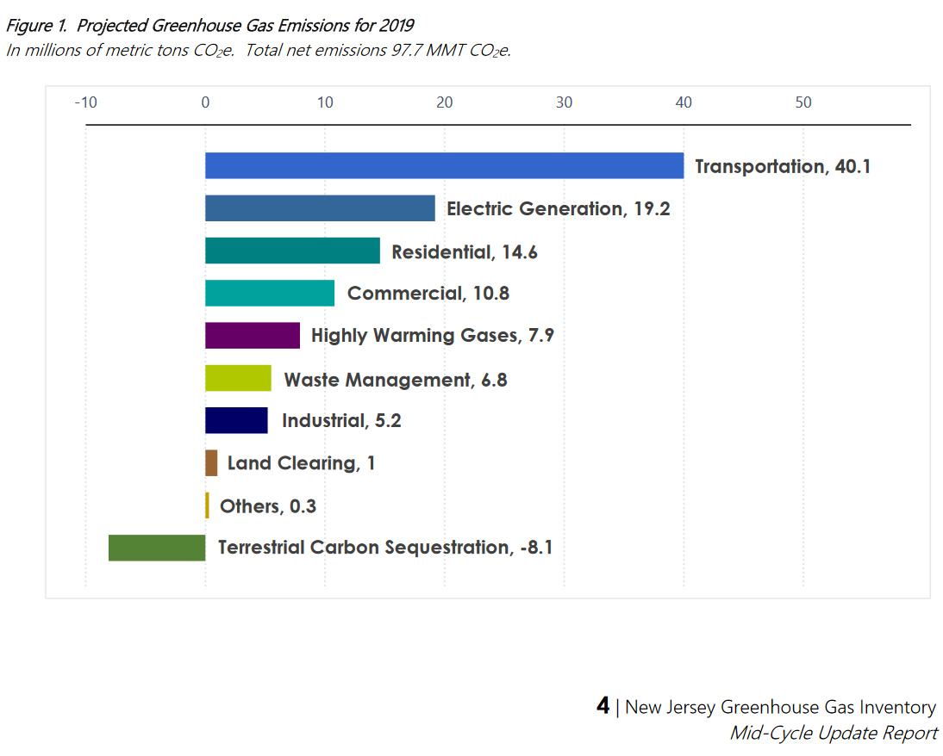

RESIDENTIAL BUILIDNG ELECTRIFICATION ACTION ITEMS
(Additional experts- TBD- may be needed to provide NJ Action Items for Commercial Buildings)
- First, ramp-up energy efficiency measures to reduce fuel usage/emissions
    - lowers operating cost
    - lower cost of building electrification conversion
    - reduces future electric load on grid
- GOAL: 900,000 fully electrified NJ residential units by 2030 (25% of residential stock)
We must provide detail of how to reach 900,000 goal.
- Building Electrification will reduce, to zero, NJ 25% Residential/Commercial Heating GHG emissions, when coupled with a source of 100% clean electricity.
- Explain need for 100% clean electric to support Building Electrification
- Provide incentives to increase the residence electric service capacity, if required to support future electric appliances and Electric Vehicles
- When EPA “Energy Star Cold Climate” is available in 2023 or later, use “Cold Climate” electric air source heat pumps (or use geothermal heat pumps where applicable) which replace polluting natural gas, oil, propane heat, and electric resistance heat (e.g. baseboard electric heat). While waiting for EPA to finalize the Energy Star Cold Climate label, reference heat pumps tested at 5 degrees, and identified on “NEEP’s Cold Climate Air Source Heat Pump List” https://ashp.neep.org/#!/ .
- Replacement for existing central A/C, and new construction (no new gas furnaces) with “Cold Climate” Heat Pumps, or “Cold Climate” Mini-Splits where appropriate. (See above discussion about using EPA “Energy Star Cold Climate Heat Pump”)
- Provide substantial incentives for electric “cold climate” heat pumps to replace existing fossil fuel space heating & AC, and electric resistance heating (e.g., “baseboard electric”) *.
- Expand incentives for electric appliances, e.g., stoves, heat pump water heaters and heat pump dryers.
- Stop all conversions of electric, oil or propane to natural gas.
- Eliminate ALL incentives for gas appliances
- Create Stretch Building Codes and Incentives for EV charger infrastructure including residential and business
- Use “heat pump” equipment to replace hot water heating & clothes dryer.
- Preferably use highly efficient “induction” cooktops instead of radiant heat cooktops.
- Develop cost model to demonstrate savings, break-even year, etc.
- Evaluate “cold climate” heat pump refrigerant. Is this an issue for Building Electrification?
- Ensure available:
      - list of “Energy Star: “cold climate” heat pumps (see discussion, above)
      - list of “cold climate” heat pump installation contractors
      - list of heat pump water heaters and dryers
- Summarize NJ (heat pump & appliance) rebates. How to improve them?
- Summarize Federal rebates and legislative status.
- What are the “code” action items that support Building Electrification?
      - Examine NEEP stretch codes – is this best model for NJ?
      - Examine if stretch building codes could be indirectly mandated (add to required municipal Master Plan updates?)
- Develop renewableheatnowNJ.org Building Electrification website that outlines the problem, goals, bills, points to NJ rebates, covers the topics above, etc. See https://renewableheatnow.org/
- Convert NY Bill Sheet to NJ Bill Sheet & develop NJ “talking points”
- Develop Legislative Agenda, Bills, and legislative/lobbying strategy & plan.
- Create NJ equivalent of following “Renewable Heat Now Legislative Package”:

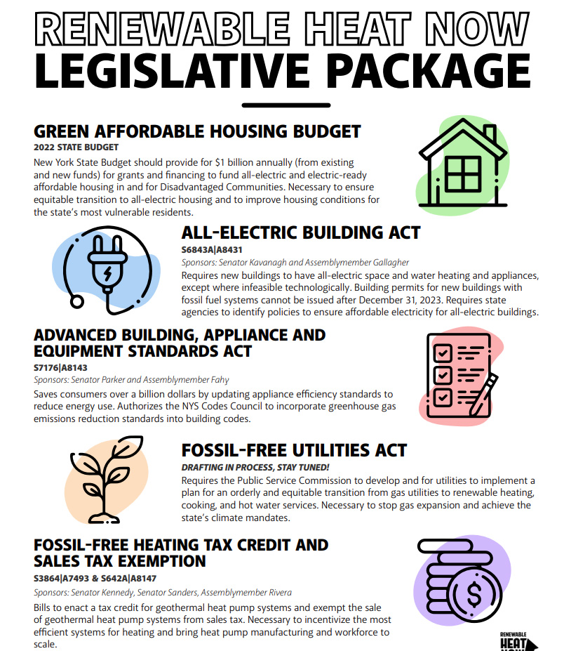
CLEAN ELECTRIC SUPPLEMENT
This section is to help launch the “ENERGY GROUP”. The following are the most significant recommendations:
- Recommend the NJ BPU closely evaluate a promising proposal to increase renewable electric content in both NJ, and in the PJM region. This proposal begins with “Implement a PJM-wide or New Jersey-only Integrated Clean Capacity Market (ICCM)”.
- For maximum rollout of “Building Electrification”, certain “actions” are required by the “Energy Group”, such as creating incentives for upgrades to Electrical Service Entrance Capacity for many residences, and likely some businesses.
- Consider developing a “Carbon Reduction Model”- shown on last page.
- Consider NJ GHG emission gap to reach 50% reduction by 2030, as described by Mike Winka (former BPU Senior technical advisor to the BPU President) in the Dec 16 webinar of the “50x30 Team”. Mike was the lead speaker in this recording: https://www.youtube.com/watch?v=BBmaMbgjij0 Mike’s slides are found at Winka-slides-pdf; or Winka-slides-PPTX

100% Clean Electric – Statistics
- NJ electric generation for 2021: ~ 52 TWH (only 2.9 TWH renewables)
- NJ offshore wind goal is 7.5 GW by 2035 (3.7 GW currently planned)
- Thus wind is estimated at 32% of routine electric needed by 2035
- NJ installed solar power at 2740 MW or 4.2% of NJ electric in 2018
- NJ incentives established to obtain projected 3750 MW solar by 2026 and seeks solar at 10% of consumption by 2050
- Thus solar and wind generation extrapolates by 2035 to an average of ~40% of existing NJ electric consumption. But also needed is clean electric to power Electric Vehicles and Building Electrification as natural gas, propane and oil are replaced.
- Thus existing NJ wind and solar projections fall far short of anticipated need for renewable electric. Far more needs to be done!
- “The Biggest U.S. Electrical Grid Braces for Green Energy” (Bloomberg 8/10/21) regarding PJM pool to which NJ belongs. Also see EIA data

100% Clean Electric – Action Items
- Ensure grid transport, capacity, peaking, backup, and resiliency
- Expand incentives for residential and business solar
- Expand incentives for community solar
- Provide incentives for building electric service renovation to support electric appliances and Electric Vehicles
- Incentives for Electric Vehicle purchase
- Incentives for EV charger infrastructure including residential and business
- Provide strong Building codes to support the above
- See 2019 NJ Energy Master Plan for numerous heat pump references
- Implement the 7/21/21 Petition Request to NJ DEP to implement 50% GHG reductions by 2030 from 2005 levels, including Clean Energy Portfolios to avoid fossil fuel infrastructure . Here is NJ DEP denial of the petition.
- Fix the NJ Renewable Portfolio Standard for electricity so it gets to 100% by 2035. Currently, it terminates at 50% for the years 2030 to 2033, thus falling far short.
- Strengthen NJ RGEA (Renewable Government Energy Aggregation). Currently there is only small participation. Municipalities and counties need stronger incentives for RGEA. Provide strong NJ state central administrative support and contracting, instead of relying on 565 NJ municipalities to provide their own.
- Offer a state wide customer RGEA option.
- Implement a PJM-wide or New Jersey-only Integrated Clean Capacity Market (ICCM). Review report by NJ BPU staff:
- 92% Clean Energy can be achieved by 2030 ( Figure 15, page 48, copied below)
“achieving 90%+ percent of clean energy can be achieved at modest costs through a PJM-wide or New Jersey-only ICCM approach to resource adequacy” (Page 5) NJ BPU Report June 2021
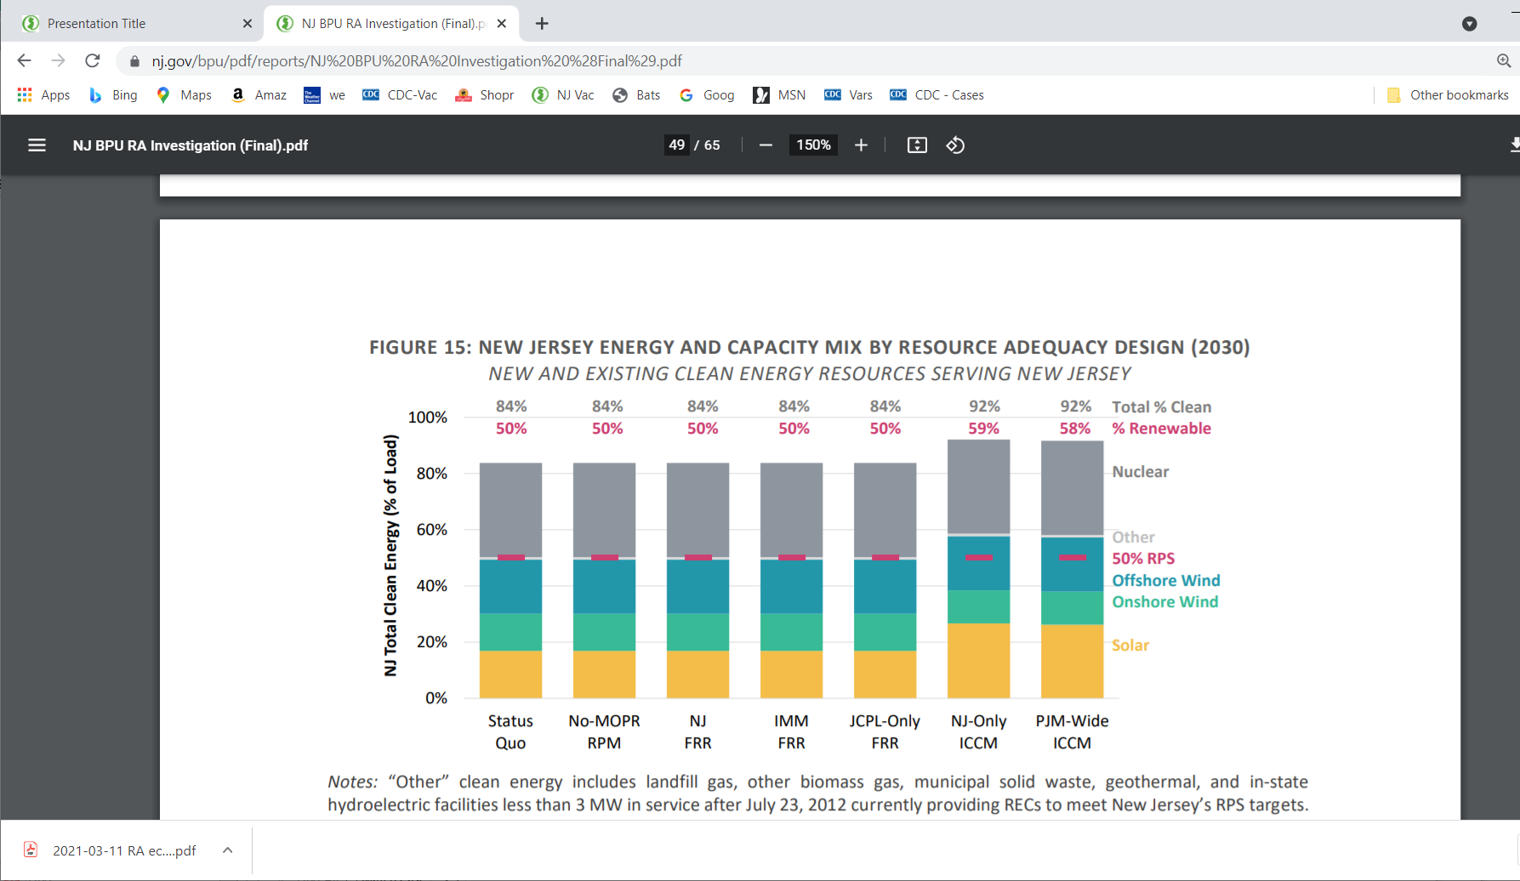
Develop a carbon reduction model (view this unsupported example)

Net Zero Carbon buildings can be new, or remodeled, and have implemented efficiency and design strategies to ensure they can produce on-site, or procure, enough carbon-free renewable energy to meet annual energy consumption of building operations. In addition, the BE team will consider new net zero carbon standards, being adopted world-wide, which also evaluate the net embodied carbon from building construction and life-cycle reuse of the building components.
Terawatt hours Based on EIA NJ May 2021 projected annually
https://www.njcleanenergy.com/renewable-energy/programs/nj-offshore-wind
Wind estimated at 16.4 TWH annually on assumption of 25% power generation for 24 hours based on https://www.totemcontracting.com/how-much-energy-do-wind-turbines-produce/
https://en.wikipedia.org/wiki/Solar_power_in_New_Jersey
7/29/21 https://www.njspotlight.com/2021/07/nj-solar-sector-new-development-incentives-adopted-target-rapid-increase/
https://www.nj.gov/dep/rules/petition/pet20210721.pdf
https://www.nj.gov/dep/rules/petition/pet20210721noa.pdf
https://www.state.nj.us/oal/rules/accessp/
“Alternative Resource Adequacy Structures for New Jersey”, NJ BPU report, June 2021. See page 5, and also, Figure 15 page 48 https://nj.gov/bpu/pdf/reports/NJ%20BPU%20RA%20Investigation%20%28Final%29.pdf

