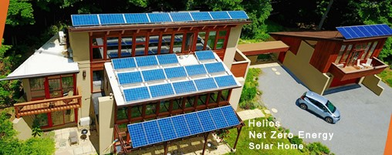

Concerned about high energy bills? Or about air pollution in our homes and outdoors? Not to mention climate change?

On Thursday, April 21 at 7 pm, we feature a new environmental program called "Building Electrification," about how each of us can go "all electric" to deal with all these problems.
Speakers are Steve Miller of the Sierra Club's N.J. Chapter and Ken Dolsky of EmpowerNJ *.

They will explain ways to:
- Conduct an energy survey of your home to immediately reduce your heating and cooling bills;
- Switch from gas or oil heat to a new all-in-one heating and cooling technology, called air-to-air heat pump;
- Understand methane’s inordinately powerful role in global climate change and as a toxic gas in your home.
You'll be glad you attended. So will the Earth.

Your friends at EmpowerNJ and the NJ Chapter of the Sierra Club

* EmpowerNJ is a consortium of more than 100 N.J. environmental organizations, including the N.J. Chapter of the Sierra Club

