INDEXED CONTENTS OF “CHAT”, Sept 25, 2023
BUILDING ELECTRIFICATION WEBINAR (Ask Sean Show)
REFERENCES AND ANNOUNCEMENTS
Recent articles (~400) in 50 categories, including Building Electrification and related topics like the IRA: https://climate.smiller.org/REF/
View your personal IRA benefits: https://www.rewiringamerica.org/app/ira-calculator
This site has specs and Energy Star compliance for all manufacturer's heat pumps and indoor air handlers https://ashp.neep.org/#!/product_list/
Redwood Energy: EXCELLENT ALL-in-ONE manual: https://www.redwoodenergy.net/research/a-pocket-guide-to-all-electric-retrofits-of-single-family-homes
For the NJ rebates, tax credits, and income limitations, see https://docs.google.com/document/d/10vSXEtbjYZ3fBYhZbBahOLVxXrn82QKHkJGHGTRnvyg/edit
QUESTIONS ARE WELCOME! Jot questions into chat. We have a team of experts eager to help provide answers
AARP BUILDING ELECTRIFICATION VIDEO This Oct 4, 2023 video was the launch of the introductory California AARP program called "Power Your Savings". The Oct 4 program had an EXCELLENT BUILDING ELECTRIFICATION introduction by Brian Stewart, of Electrify Now. The program is for AARP members to make energy-efficient changes to their homes and utilities, much like what this series of seminars is doing here in NJ. The objective is to show a great deal of interest in the California program, and try to replicate with the NJ state AARP,
And if anyone is interested in helping us bring NJ AARP on board our Building Electrification campaign, please sign the petition at https://SupportAARPClimateAction.org/petition with an appropriate comment.
ALWAYS BUY "ENERGY STAR" appliances in order to be eligible for tax credits and rebates

COMPILED QUESTIONS
ELECTRICAL PANEL, BREAKERS and WIRING
It looked like that was two 100 amp circuit breakers ganged together, implying 200 amps. Is that because it’s for a 240 volt service?
Dan it's a two pole 100 amp breaker
Tom Kabat (Calif Energy Engineer): The amount of power available on a 100 Amp panel is: 2 poles X 120 Volts per pole X 100Amps of current flow on each pole = 24,000 Watts = 24 kW of power
Dan Can you put 10kw through a 200amp panel?
Tom Kabat (Calif Energy Engineer): @ Dan a 200Amp panel can deliver 48 kW to the home and it can accommodate a solar inverter putting out 9.6 kW AC and that can be powered by a clipping inverter with up to 16 kW of Solar DC rated PV panels. (The clipping ratio depends on the inverter brand and model.)
John W Does she [Kristen] have a spot for the 50amp breaker for the stove in her panel
Carol Replying to "Does she have a spot..." That's what added a lot to the cost of installing mine
Tom Kabat (Calif Energy Engineer): @ John yes, Tandem thin breakers will work like this one I’m holding. 50A middle and 30 Amps outer levers.
Steve Miller: Electrical wiring and electricians who do the wiring are paid up to $2500 by a separate category for the REBATES that the NJ BPU is expected to pay in 2024. I believe that plumbers are paid when needed as part of the total installation (Example: heat pump water heater as part of the installation contract.)
HEAT PUMP SPACE HEATING
Holly What if you don’t have/want an AC system just want to replace your gas furnace with a heat pump?
Tom Kabat (Calif Energy Engineer): @ Holly, you can replace the furnace with a heat pump and then not run the cooling side of it. But if you replace the furnace with just electric resistance heat, it takes 3 times as much power and electricity to do the heating compressed to a good heat pump. So we recommend a heat pump even for just heating.
Carol : What about when the furnace is currently in the basement, and there are two A/C units at different spots in the attic - one in main part, one in the addition? Where would this all go?
Tom Kabat (Calif Energy Engineer): @ Carol, I’d need to see pictures of the things in the attic to better understand what they are doing. But for most homes the heat pump air handler just directly replaces the furnace in its location and the heat pump compressor replaces the AC outdoor compressor unit in its location.
Carol Thanks for addressing my question about A/C and furnace location. Basically there are two condenser units outside, side-by-side, with two different air handlers in the attic at opposite ends. One is in the main house and the other in the addition; each cools half the house.
Tom Kabat (Calif Energy Engineer): @ Carol, it sound like you could use 2 air handlers in attic.
Michael Hi! I have a 4T heat pump connected to four minisplits on our second and third floors. Our first floor has none yet. We would like ducted ac and heating - using our steam boiler only when really cold or just in the morning. Basement is unfinished and we only have three rooms and a half bath ~33’x20’. What air handlers can be used with our existing equipment? This would be new ducts.
Tom Kabat (Calif Energy Engineer): @ Michael, To match up outdoor equipment to the new central indoor air handler, this site could help you input the model number of the compressor and find matching air handlers: https://ashp.neep.org/#!/product_list/
Maryrose Can a heat pump be used with an existing hot water baseboard system? Or is better to remove the hot water baseboard entirely in favor of an air source heat pump?
Tom Kabat (Calif Energy Engineer): @ Maryrose, it depends on the temperature of water that the baseboard convectors require to heat the home. At 100F to 130F regular heat pumps are great. For hotter water delivery temps, special heat pumps might be needed.
Steve Miller (host) If your current hot water baseboard or radiators use 170 degree ("steam") water, unless an emergency, it may be better to wait a couple of years for high temperature air to water heat pumps (expected to be introduced from Europe) to directly swap-in and replace the boiler. There is intensive industry effort to have US and NJ safety and building codes accept European standard refrigerants, such as propane, which has a 100 year Global Warming Potential – GWP- even lower than CO2. Typical current refrigerants have GWP 1000 to 2000 times worse than CO2.
IS GAS FURNACE STILL NEEDED WITH HEAT PUMP SPACE HEATING?
Behnaz We got two estimates for a heat pump for our house in Montclair. We were told by both that we needed both a furnace and a heat pump to make sure we were warm in the winter. Is that correct?
Tom Kabat (Calif Energy Engineer): @ Behnaz, It sounds like a good idea to get the utility energy audit to see if some insulation can get you to needing just a heat pump to save energy and simplify things. But heat pumps need good thermostats to start earlier in the morning to hit your temperature targets on time.
Steve Miller (host): those with heat pumps are often told to leave the thermostat at one temperature, and not use thermostat night time setbacks, because it takes a long time to reach desired temperature (and may take more electricity $) than simply leaving at one temperature
INDUCTION STOVE
Dana W: Sumsung customer service is horrible though.
Carol I just replaced the gas stove - had to have the plumber cap off the gas line, and the electrician move/split circuits to set up the correct circuit.
Carol Are there any IRA or other program features that help offset the cost of the electrician or plumber for something like the electric stove replacement?
Steve Miller (host) See all NJ rebates and Tax Credits Here: https://docs.google.com/document/d/10vSXEtbjYZ3fBYhZbBahOLVxXrn82QKHkJGHGTRnvyg/edit
Dana W: There seems to be no rebate for induction stove, just installed one in July
Steve Miller (host): induction stoves and wiring will be covered in 2024 by NJ. Plumbers are not separately listed.
Tom Kabat (Calif Energy Engineer): @ Dana, the Rewiring America link site shows a 2024 $840 ($420 for middle income) upfront incentive may become available as state energy offices funnel IRA money to low and middle income households.
Pat Miller (host): IRA rebates are not yet in effect. Maybe 1st of 2024? These rebates will be for LMI only: up to 150% of area median income
HEAT PUMP DRYERS
Walter Can you talk about heat pump dryers?
Shoshana where do you buy a heat pump drier
Michael Reacted to "Can you talk about h…" with 👍🏼
Steve Miller (host): heat pump dryers are discussed on pages 12 and 64-65 of https://www.redwoodenergy.net/research/a-pocket-guide-to-all-electric-retrofits-of-single-family-homes; Home Depot lists 10 models (free delivery to your house, but only 1 on display in my local store); Lowes lists 8 models for free delivery (non seem to be on display in my local store)
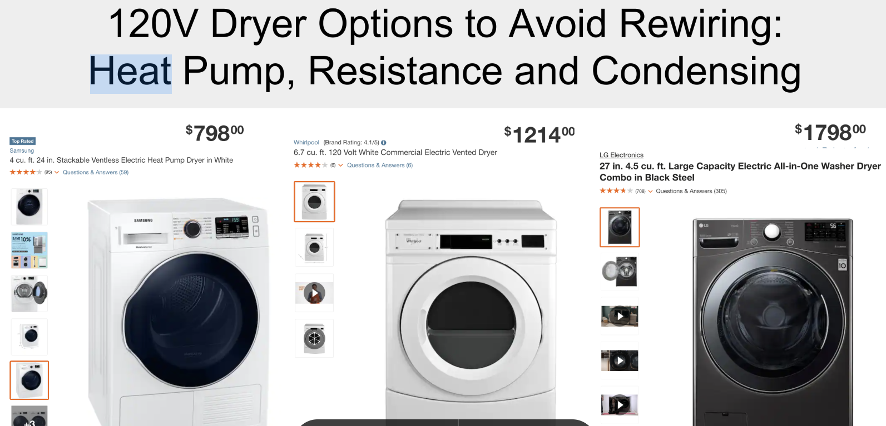

SOLAR QUESTIONS
Behnaz our roof is west and east facing (not south). Are solar panels useful to install?
Steve Miller (host): East and West facing panels will work. Check the solar panel specs- some have higher efficiency with the sun at angles
Dan Thank you. I have an old 3.7kw system. I want to install new panels for about 8kw
Michael Does the collar limit what you can send to grid if not using all solar generated?
Tom Kabat (Calif Energy Engineer): @ Michael, I don’t think the collar is limiting the flow in any direction or guiding it in any direction. It just gives a path to accommodate a larger flow of electricity.
Walter Does the [meter] collar work with NET metering?
Dan So you can just plug a solar array directly into the meter collar? And who installs meter collar?
Tom Kabat (Calif Energy Engineer): @ Dan, I think the utility installs the meter collar and then plugs their meter into it and puts a new seal on the tamper security collar
HEAT PUMP WATER HEATER
Dana W: Does heat pump work in cold weather? I need to change my gas water heater. Thanks!
Dana W: I consulted two electricians who don’t seem to recommend it.
Dana W: Yes, in basement
Michael I have a Voltex HP water heater in basement. It’s great. I did not measure temp. Just installed
Walter Korfmacher: I live in NJ and I have a heat pump water heater in my basement. It works great!
Michael And it’s not loud either. Unfinished basement right below our TV in Living Room. Steam boiler is loud by comparison.
Tom Kabat (Calif Energy Engineer): The common hybrid heat pump water heater can use the heat pump for super high efficiency down to a basement temperature of 41F. If the basement drops below that temperature, the hybrid switches to an electric resistance coil method to heat the water.
Mario it will be fine in her basement. If her basement got that cold, her pipes would freeze and burst.
June Does the heat pump water heater need a drain for dehumidifier?
Michael @June Hament We have a condensate pump
Tom Kabat (Calif Energy Engineer): @ June, Yes. My HPWH makes about a quart of water condensed as it dehumidifies my basement ( a byproduct service). I use a $75 “Condensate pump” that pumps the water out to my plants.
Tom Kabat (Calif Energy Engineer): @ June
https://www.supplyhouse.com/DiversiTech-CP-22-230-Condensate-Pump-with-22-Ft-Lift-230V?utm_source=google_ad&utm_medium=Shopping_tm&utm_campaign=Shopping_TM_New_users&gclid=CjwKCAjw38SoBhB6EiwA8EQVLhlFo6fJITM9lOI8wovFA0uiuw3MOY7VjW_D0FHRRs8BMiyrp3j-gBoCBNAQAvD_BwE
June Water heater is in center of house on concrete slab, not near garden! a condensate pump would need to drain "somewhere."
Michael @June Hament mine is about 15’ from utility sink and it has enough lift to push the water from heater to drain
Tom Kabat (Calif Energy Engineer): @ June, the common places we send that clean condensate water are: The washing machine’s drain stand pipe, the laundry sink, a floor drain. An outdoor plant. But not onto a sidewalk where it would freeze in winter.
Ira with a hot water heat pump, how long do you have to wait for hot water for a shower?
Michael @Ira Katz small house. 1450 sq Ft. Maybe 90-120 seconds to hot water.
Tom Kabat (Calif Energy Engineer): @ Ira, I switched from a gas tank water heater to an electric tank water heater. It delivers hot water just as fast. Because they are both just tanks of hot water.
Stephen Is there any difference in the effect of hard water on a heat pump hot water heater.
Tom Kabat (Calif Energy Engineer): @ Stephen, I’m not sure. But maybe the 1,600 degree F flame of the gas water heater causes more water chemistry issues than the 130F refrigerant would cause. I remember hearing my gas water heater make boiling sounds if I dropped the pressure by turning on the tap.
GEOTHERMAL
Joanne My 12 year old geothermal waterfurnace must be switched from cold to hot. These heat pumps don’t?
Tom Kabat (Calif Energy Engineer): @ Joanne, I just switch my thermostat mode from cooling to heating mode in the winter at the push of a button.
TANKLESS WATER HEATERS
Carol Any thoughts about tankless water heaters? Do they make those as heat pump style, please?
Tom Kabat (Calif Energy Engineer): @ Carol, My thoughts are to avoid tankless water heaters ( gas or electric) tank water heaters provide faster hot water, since they are already hot.
PROPANE: the FUTURE "FREON"
Dan: propane is flammable!
Steve (host): the world’s refrigerant industry is working to get the US/states/local safety and building codes to accept propane (& other refrigerants), which are currently used in Europe and elsewhere. Most promising for U.S. safety acceptance is air to water heat pumps where the propane (or other refrigerant) is a small quantity totally within the outside condenser. (References: Oct 9 2023 “Low GWP Refrigerants” Recording; Slides and this 2022 technical report )
This might lead to heat pump drop-in boiler replacements for radiator heating, common in parts of the US.
Mark: Propane as in the fossil fuel propane?
Tom Kabat (Calif Energy Engineer): @ Mark Yes that same fluid can be an efficient phase change refrigerant.
Dan propane does not have a similar absorbance spectrum to Methane?
Tom Kabat (Calif Energy Engineer): @ Dan, the GWP of CH4 (methane ) is 86 times as high as the same weight of CO2, the GWP of C3H8 (propane) is only 3 times as high as the same weight of CO2.
CONTACT INFO
Sean Armstrong: https://www.redwoodenergy.net/research
Sean Armstrong: https://www.redwoodenergy.net/research/a-pocket-guide-to-all-electric-retrofits-of-single-family-homes (this is an EXCELLENT all-in-one guide)
Sean Armstrong: seanarmstrongpm@gmail.com
Tom Kabat (Calif Energy Engineer): tomgkabat@gmail.com
NJ VOLUNTEERS ARE ENCOURAGED TO FEATURE THEIR PERSONAL “CASE STUDY” during monthly Building Electrification webinars. We will help you. Provide your case study proposal to stevemiller@comcast.net

