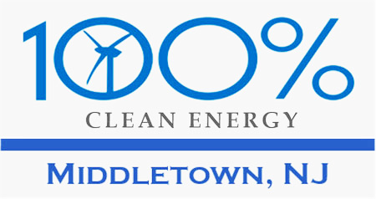
Sept 14, 2020
Whereas Middletown Township is proposing a one cent tax increase per $100 equalized valuation to fund additional acquisitions and improvements to open space and parkland in the township
And whereas Middletown for Clean Energy works toward a town (and world) where our children and grandchildren can flourish (i.e., leave Middletown and the world better than we found it).
And whereas our mission is to make Middletown a leader among NJ towns in committing to and achieving zero Green House Gas emissions by 2050.
And whereas this proposal is in accord with a nationwide movement to protect land and water which research shows could result in a 21% reduction in net annual U.S. GHG emissions *
And whereas this proposal could serve as a model for all New Jersey communities to preserve much of the Garden State's remaining open space,
Middletown for Clean Energy endorses and supports the Middletown Township proposed one cent increase in dedicated tax levy per $100 equalized valuation, to fund additional acquisitions and improvements to open space and parkland properties.

Steve Miller,  Co-founder, Middletown for Clean Energy | Pat Miller  Co-founder, Middletown for Clean Energy
* Natural Climate Solutions for the United States https://www.ncbi.nlm.nih.gov/pmc/articles/PMC6235523

