CURRENTLY:
- Organized a group to create Practical Guides for Consumers – to understand and use the best of the IRA, Infrastructure Bill, and current and future NJ rebates (which will “Stack” with the Federal incentives)
- Our BE group is settling our in-person and written input to a NJ BPU Stakeholder meeting April 6. (Pat is signed up to talk). The topic is IMPORTANT: Gov Murphy’s EO 316 set a goal: an additional 400K residences and 20K businesses ELECTRIFIED by 2030. (one of the goals we asked the Gov to set). The April 6 meetings with the BPU and all NJ utilities sets THEIR work program on Energy Efficiency and building electrification, from July, 2024 to June, 2027. Our goal: NJ budget is sufficient to provide the incentives, to drive an ADDITIONAL 60K/year residents and businesses to adopt cold climate Heat Pumps and completely electrify their buildings.

The Climate Reality Project and NJ 50x30 Building Electrification Team
INCREASE HOME ENERGY EFFICIENCY, VALUE, and SAVINGS
Techniques for your house to reach "Net Zero"
JOIN US, 7PM, April 20. REGISTER HERE to receive the Zoom link
Our first topic is "Best Practices Using Heat Pumps in Energy Efficient Buildings". Bill Amann, President, M&E Engineers, will quickly review heat pump basics, and then discuss relative efficiencies and selection criteria among many possible system designs, depending upon building characteristics. He will also discuss the most recent energy efficiency code, and problems with policing compliance.
Our 2nd speaker, Alan, will review his design decisions for his all-electric beautiful 4 story “beach house”. He will discuss the value of the Tesla solar tile replacing the traditional roof, and the challenges with maximizing his roof with solar coverage to reach "Net Zero". His design includes 4 Tesla PowerWalls to provide backup generation and non-grid power during nighttime and cloudy days. His house will have 3 indoor electric fireplaces (tightly sealed-no vents); 3 outdoor fireplaces; outdoor BBQ; radiant floors; jacuzzi and pool
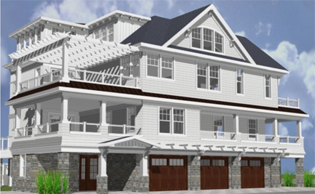

Techniques To Reach "Net Zero"
JOIN US, 7PM, May 18. REGISTER HERE to receive the Zoom link
Join us May 18, when we review “best in class” data and money-saving opportunities from over a year of building electrification webinars.
Following is one house example. 23% $savings, and 83% GHG reduction achieved (Jan 6, 2022 through Jan 6, 2023) by substituting a heat pump to replace a broken outdoor air conditioner condenser:
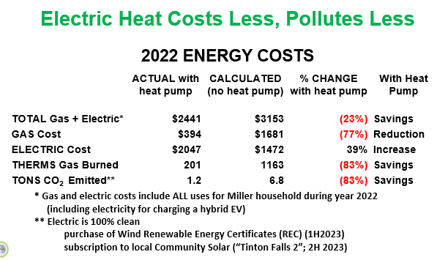
OUR ASK: IF YOU UPGRADE YOUR HOUSE , OR buy an EV, LET US KNOW YOUR SAVINGS, SO WE CAN PUBLICIZE! (anonymous if you wish)

