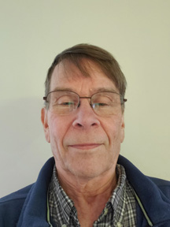 Name: Steve Miller
Training Attended: Denver 2017
How long have you lived in NJ: 50 years
Length of membership in any chapter: 5 years (incl. Central Jersey, Jersey Shore)
Committee you would like chair: 50x30 Team
What you would like to see the committee work on in 2022:
The “50x30 Team” mission is to educate individuals, and advocate officials at local, state, and national levels to urgently work toward 50% GHG reduction by 2030, and NetZero by 2050. Climate Reality Leaders and all others are welcome to join us. Meets 3rd Thursday of the month at 7 PM. The 50x30 Team was created by Steve and Pat Miller as a CRP GNJG Chapter subcommittee in August 2021.
Reducing emissions in 3 sectors is key to achieving the goal: 1) switch to clean electricity generation, 2) electrify transportation, and 3) electrify building heat. The 50x30 team has focused on educational webinars, meeting with or writing to key governmental officials advocating for particular legislation or policies and promoting activism among chapter members and others. For the immediate future, we plan to focus on advocating for NJ to more quickly (earlier than the stated 2030 start date) adopt building standards to electrify building heat and hot water.

