Climate Reality Project and NJ 50x30 Building Electrification Team
INCREASE HOME ENERGY EFFICIENCY, VALUE, and SAVINGS
Start in your own home to reduce your climate-changing Green House Gases.
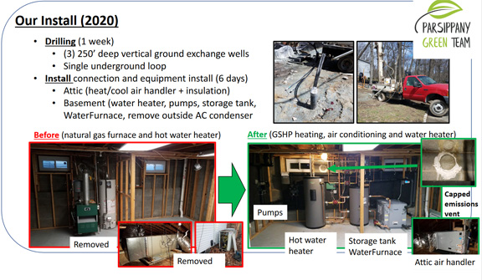
PICTURED: Ground Source installation for SPACE HEATING, A/C, and WATER HEATING
Join our Oct 20, 7PM monthly webinar, “Electrifying Buildings: Real Life Stories”
(We feature 3 speakers. This is our 10th webinar on related topics).
REGISTER HERE to receive Zoom link (requires RSVP): https://bit.ly/3tmyd1g
(Registration will add you to our email list for future webinars. Opt-out at any time).

We bring back lead speaker “Scott Nelson”. Scott owns a large HVAC business, is a board member of the NJ Air Conditioning Contractors Assoc. and will provide a heat pump dealer's view of consumer HVAC options. He and his large team of people keep up-to-date on the latest technology to improve building comfort.
We showcase Matt, Parsippany Green Team co-Leader, who describes his ground source heat pump, solar roof, energy storage, amped-up insulation, and two hybrid EV vehicles. Matt’s home is a role model for Building Decarbonization leading to near Zero GHG.
We feature Jordan Stern, president of Platsky and Platsky hvac, which represents manufacturers from around the world for the utility, hvac and plumbing industries. Platsky has technical experts who support engineers, contractors, architects and other construction experts on how to integrate new technology products into the existing design world.

