Sierra Club NJ Chapter and NJ 50x30 Building Electrification Team
“Electrifying Buildings: Real Life Stories”
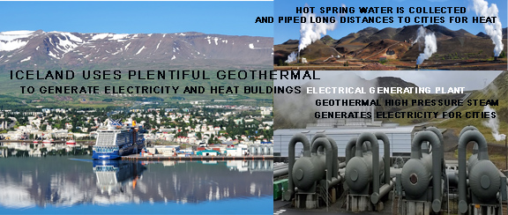
Start in your own home to reduce your climate-changing footprint.
You are cordially invited to our September 15, 7PM webinar, “Electrifying Buildings: Real Life Stories”. Our lead speaker is “Ingo” 'Ingólfur Páll Matthíasson' a climate activist, and resident of Iceland (Land of Fire and Ice), with a fascinating talk including Iceland's use of abundant geothermal energy to reduce Green House Gases.
Jennifer and Dean then describe their personal experiences with air source heat pumps for house and water heating and induction stove.
Finally, Matt describes his solar system, amped up insulation, ground source heat pump and an energy storage system, an EV charger and two hybrid vehicles.
REGISTER HERE to join NJ 50x30 Building Electrification Team’s Sept 15, 2022 webinar at 7 pm

