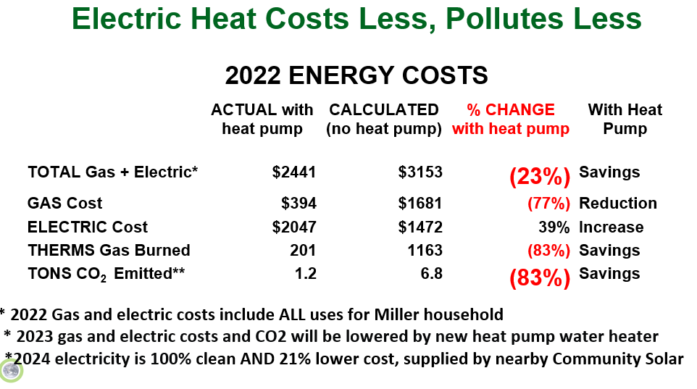
- Above data is based upon June, 2023 calculations by S. Miller, 151 Borden Rd, Middletown, NJ
- House is 2 story plus partially finished full basement. The 1st and 2nd floors are each central ducted forced air 3 ton A/C + Gas furnace
- On 1/6/2022 replaced the (broken) 1st floor AC condenser with a 3 ton single stage classic heat pump ($4900 total cost); the 6 year old gas furnaces remain as low temp backup
- Large open central core/stairs allows heat to flow from 1st to 2nd floor (air flow aided by a small fan)
- No GHG emissions from electricity generation; 2022 electricity is supplied by purchases of RECs for wind-generated electricity

